A reproducible reliability benchmark for non-stationary liquefaction probability under groundwater and gradation-change scenarios
Gabriel J. Montufar Chiriboga
Universidad de Panama, Panama. Corresponding author: gabriel.montufar@up.ac.pa

Abstract
Liquefaction assessments are commonly reported as a factor of safety or as a probability for a fixed groundwater condition and a fixed soil gradation. That representation is convenient for design checks, but it is incomplete when the groundwater table and the gradation of potentially liquefiable layers can evolve during the service life of an engineered system. This paper proposes a reproducible non-stationary reliability benchmark for estimating liquefaction probability under coupled groundwater and gradation scenarios. The framework defines a time-dependent limit-state function using cyclic stress ratio, cyclic resistance ratio, fines-content correction, model uncertainty, groundwater depth and layer-wise soil variability. A transparent four-layer profile is evaluated with Monte Carlo simulation across prescribed states in a 50-year planning horizon under stationary, rising, seasonal and extreme groundwater scenarios, combined with constant gradation, fines accumulation and fines washout. The benchmark compares deterministic, stationary-probabilistic and non-stationary probabilistic assessments. The results show that shallow layers that appear marginally stable under a stationary calculation can reach substantially higher computed probabilities of liquefaction when groundwater rise, extreme events and gradation evolution are considered. The contribution is not a new empirical triggering curve; it is an auditable workflow for converting liquefaction assessment into a scenario-conditioned probability indicator for geohazard screening-oriented analysis. The benchmark is intended for reproducible screening and trend-consistency evaluation rather than site-specific design calibration.

Keywords
liquefaction; geotechnical reliability; geohazard risk; groundwater; gradation; non-stationary modelling

1. Introduction
Simplified liquefaction procedures remain central to geotechnical earthquake engineering because they transform site investigation data and seismic demand into an interpretable triggering index [32, 33, 38, 12, 4]. Probabilistic extensions of these procedures acknowledge epistemic and aleatory uncertainty in demand, resistance and model form [5, 24, 15, 16]. However, many practical assessments remain effectively stationary: the groundwater table, fines content and soil index parameters are treated as fixed descriptors of the site rather than as variables that may evolve during the planning horizon.
Recent probabilistic liquefaction studies already address important parts of this problem. Modern PLHA and performance-based procedures integrate ground-motion hazard, triggering uncertainty, settlement consequences, regional screening and groundwater uncertainty [43, 45-48]. Those studies motivate the present work, but they also define its boundary: this manuscript does not claim a new regional hazard model, a new settlement model or a new triggering correlation. Its narrower contribution is a compact reproducible benchmark that isolates prescribed non-stationary groundwater and gradation states within the same disclosed layer-wise probability workflow, so that the scenario effect can be audited directly.
Table 1 summarises representative recent and established work against the specific benchmark gap addressed here. The comparison shows that probabilistic triggering models, PLHA tools, regional mapping studies and open geospatial engines already treat important components of liquefaction uncertainty, including groundwater as an input. The missing element targeted by this paper is narrower: a compact, runnable benchmark that isolates prescribed non-stationary groundwater and fines/gradation states in the same layer-wise Pf(t) workflow.
Table 1. Position of the proposed benchmark relative to established and recent probabilistic liquefaction work.
Study | Scale/data | Uncertainty | Groundwater | Fines/gradation | Temporal treatment | Assessment/reproducibility | Gap relative to this benchmark
Cetin et al. [5] | SPT case-history triggering | Probabilistic triggering model | Implicit/site input | SPT-based corrections | Stationary | Case-history model | No prescribed groundwater/gradation trajectories or open layer-time benchmark
Moss et al. [24] | CPT case-history triggering | Probabilistic CPT model | Implicit/site input | CPT soil behavior terms | Stationary | Case-history model | No non-stationary scenario benchmark
Kayen et al. [16] | Vs-based triggering | Probabilistic Vs model | Implicit/site input | Vs proxy, not gradation evolution | Stationary | Case-history model | No prescribed fines/gradation scenarios
Yang and Wei [39] | Vs/logistic model | Model uncertainty via logistic regression | Not central | Fines content emphasized | Stationary | Published model | Supports fines sensitivity but not coupled groundwater-gradation trajectories
Greenfield et al. [43] | Regional extension | Soil, groundwater and manifestation uncertainty | Explicit uncertainty | Regional soil classification | Regional/static | Regional evaluation | No compact open benchmark isolating prescribed state trajectories
Makdisi and Kramer [46] | PLHA computation | Hazard-space and triggering uncertainty | Site/regional input | Not focus | PSHA/hazard return periods | Computational method | Addresses PLHA, not synthetic non-stationary groundwater/gradation paths
Ordaz et al. [47] | Event-based PLHA | PSHA/event uncertainty | Model input | Not focus | Event-based annual hazard | PLHA framework | Distinguishes annual hazard from this state-conditioned Pf(t) benchmark
Olaya et al. [48] | Performance-based settlement | Ground-motion and settlement uncertainty | Input variable | Not focus | Performance-based hazard | Procedure assessment | Focuses settlement, not layer-wise Pf(t) scenario mechanics
Javanbakht et al. [49] | 787 CPTs, regional mapping | Model and soil resistance uncertainty | Regional input | CPT resistance, not evolution | PSHA/hazard mapping | CPT database available | Regional mapping; not reproducible synthetic benchmark for prescribed gradation change
Cruz et al. [45] | Review of urban PLHA | Synthesis of uncertainty sources | Recognized driver | Recognized susceptibility input | Review-level | Literature review | Shows field is active but not a runnable benchmark
OpenQuake/GEM [50] | Geospatial HAZUS/secondary perils | Scenario/event PSHA inputs | Required input; sensitivity recommended | Susceptibility class | Scenario/event-based | Open-source engine/docs | Open platform uses groundwater but not the proposed layer-wise gradation trajectory benchmark
Hu et al. [41] | 234 gravelly cases | Observed case-history variability | Observed descriptor | Gravelly-soil descriptors | Event observations | Open dataset | Used here only for trend-consistency, not calibration of synthetic Pf(t)
This assumption is restrictive for geohazard risk management. Groundwater levels are influenced by climate, pumping, drainage, land-use change, coastal conditions and extreme events; therefore, hydrologic stationarity cannot be assumed without examination [23, 13]. Gradation may also change in susceptible fills, hydraulic deposits, erodible layers or zones affected by internal erosion and suffusion [17, 34, 37]. These changes do not merely alter a descriptive parameter. They modify effective stress, cyclic stress ratio, clean-sand equivalent resistance and the probability that a layer will reach a liquefaction limit state.
Geotechnical reliability provides a natural language for this problem because it connects soil variability, model uncertainty and performance probability [3, 1, 8, 22]. The approach is also consistent with a broader geo-engineering scope involving uncertainty, geohazards, reliability-based design, decision analysis and risk management. The central gap addressed here is the absence of a compact, reproducible benchmark that compares stationary and non-stationary liquefaction probability under explicit groundwater and gradation scenarios.
The paper makes three explicit contributions for geoscience and geohazard screening. First, it formulates liquefaction triggering as a time-dependent limit-state problem in which groundwater depth and gradation are auditable state variables. Second, it provides a reproducible Monte Carlo benchmark with code, CSV outputs, figures, convergence checks, sensitivity diagnostics and an external trend-consistency check. Third, it separates deterministic, stationary-probabilistic and non-stationary probabilistic interpretations so that reviewers can see how prescribed groundwater and gradation-change scenarios alter computed liquefaction probability within the benchmark assumptions. The contribution is deliberately methodological: the synthetic profile is a transparent benchmark rather than a calibrated field site, and the numerical results should be read as workflow evidence rather than as a site-specific hazard statement.

2. Background and reliability gap
Liquefaction triggering is usually assessed by comparing cyclic resistance ratio, CRR, with cyclic stress ratio, CSR. Classical procedures rely on SPT, CPT or shear-wave velocity correlations and are supported by case histories [28, 29, 14, 18]. Although deterministic safety factors are useful, they hide the uncertainty in soil resistance, seismic demand, stress reduction, fines correction and model error. Reliability-based geotechnical analysis addresses this limitation by representing uncertain quantities as random variables or random fields [25, 36, 20, 9, 2].
Risk-based liquefaction assessment also needs temporal structure. A probability computed at one groundwater level does not automatically describe future states of the site. Similarly, a fines correction applied to a single gradation curve may not represent a deposit affected by fines accumulation, washout or compositional change. Unsaturated and partially saturated soil mechanics emphasises the role of pore pressure, suction and water retention in effective stress, although the present benchmark remains on the saturated triggering side of the problem and uses groundwater position as the main hydraulic state variable [10, 21, 11].
From a decision perspective, the relevant question is not only whether the present-day factor of safety exceeds one. A port, coastal fill, urban lifeline or reclaimed site may require a screening indicator that can be compared across prescribed future states. The proposed benchmark therefore reports Pf(t), layer-wise and profile-wise changes in probability, and the difference between stationary and non-stationary estimates. In this paper, Pf(t) denotes the scenario-conditioned probability at a specified groundwater-depth and gradation state; it is not an annualized probability or a cumulative probability of liquefaction occurrence over the full 50-year planning horizon. This aligns with simulation-based reliability and sensitivity analysis practice [30, 35, 31, 27, 26, 6].

3. Non-stationary reliability formulation
For a layer at depth z and time t, liquefaction is represented by a limit-state function g(z,t). The layer is considered to liquefy when g(z,t) < 0. The benchmark uses the following factor-of-safety form:
g(z,t) = FS(z,t) - 1
FS(z,t) = CRR(N1,60cs(t), FC(t)) / [CSR(PGA, z, zw(t)) * MSF * epsm]
Here N1,60cs is the clean-sand equivalent corrected SPT resistance, FC(t) is fines content, zw(t) is groundwater depth, PGA is peak ground acceleration, MSF is a magnitude-scaling factor and epsm is multiplicative model uncertainty. Liquefaction probability is then estimated as:
Pf(z,t) = Pr[g(z,t) < 0]
The benchmark intentionally keeps the empirical triggering functions simple so that the effect of non-stationarity remains auditable. CSR is computed with the standard simplified stress-ratio structure, while CRR is represented by a bounded smooth relation with corrected SPT resistance. The objective is not to replace established triggering curves, but to show how they can be embedded in a time-dependent reliability calculation.
Table 2 summarises the main uncertain inputs and links the limit-state equations with the reproducible code.
Table 2. Random variables and deterministic state variables used in the benchmark.
Variable | Role | Representation
N1,60 | SPT resistance index | Lognormal, layer-specific mean, coefficient of variation implied by sigma = 0.18
FC(t) | Fines-content state variable | Normal around scenario mean, truncated to 0-45%
zw(t) | Groundwater depth | Normal around scenario trajectory, truncated to 0.4-7.0 m
PGA | Seismic demand intensity | Lognormal with median 0.28 g
epsm | Model uncertainty multiplier | Normal with mean 1.0 and standard deviation 0.12
rd(z) | Stress-reduction coefficient | Depth-dependent deterministic approximation

The four-layer synthetic profile in Table 3 represents a shallow deposit with decreasing susceptibility with depth. It is not a hidden calibration case; all parameters are disclosed so that reviewers can rerun or modify the benchmark.
Table 3. Synthetic layered profile used for the reproducible benchmark.
Layer | Depth z (m) | Thickness (m) | N1,60 | Initial FC (%) | D50 (mm)
L1 | 2.0 | 2.0 | 10.0 | 8.0 | 0.33
L2 | 4.5 | 3.0 | 13.0 | 14.0 | 0.25
L3 | 8.0 | 4.0 | 18.0 | 21.0 | 0.18
L4 | 12.5 | 5.0 | 24.0 | 28.0 | 0.14

The groundwater and gradation scenarios in Table 4 define the non-stationary dimension. The extreme scenario introduces a discrete groundwater rise after year 30, while the gradation scenarios represent constant, accumulating and washing fines contents.
Table 4. Non-stationary scenarios evaluated in the benchmark.
Scenario group | Scenario | Definition
Groundwater | stationary | Constant mean groundwater depth
Groundwater | rising | Long-term shallowing of groundwater at 0.035 m/year
Groundwater | seasonal | Mild trend plus sinusoidal oscillation
Groundwater | extreme | Trend, oscillation and a discrete extreme groundwater rise after year 30
Gradation | constant | No change in fines content
Gradation | fines_accumulation | Increase of fines content by 0.10 percentage points/year
Gradation | fines_washout | Decrease of fines content by 0.08 percentage points/year

4. Reproducible benchmark results
The complete benchmark contains 1,248 layer-time-scenario records generated with 12,000 Monte Carlo samples for each state. The CSV files, Python script, README and regenerated figures are provided as Online Resource 1. Fig. 1 shows the time evolution of layer-wise non-stationary liquefaction probability for the extreme groundwater scenario with fines accumulation.
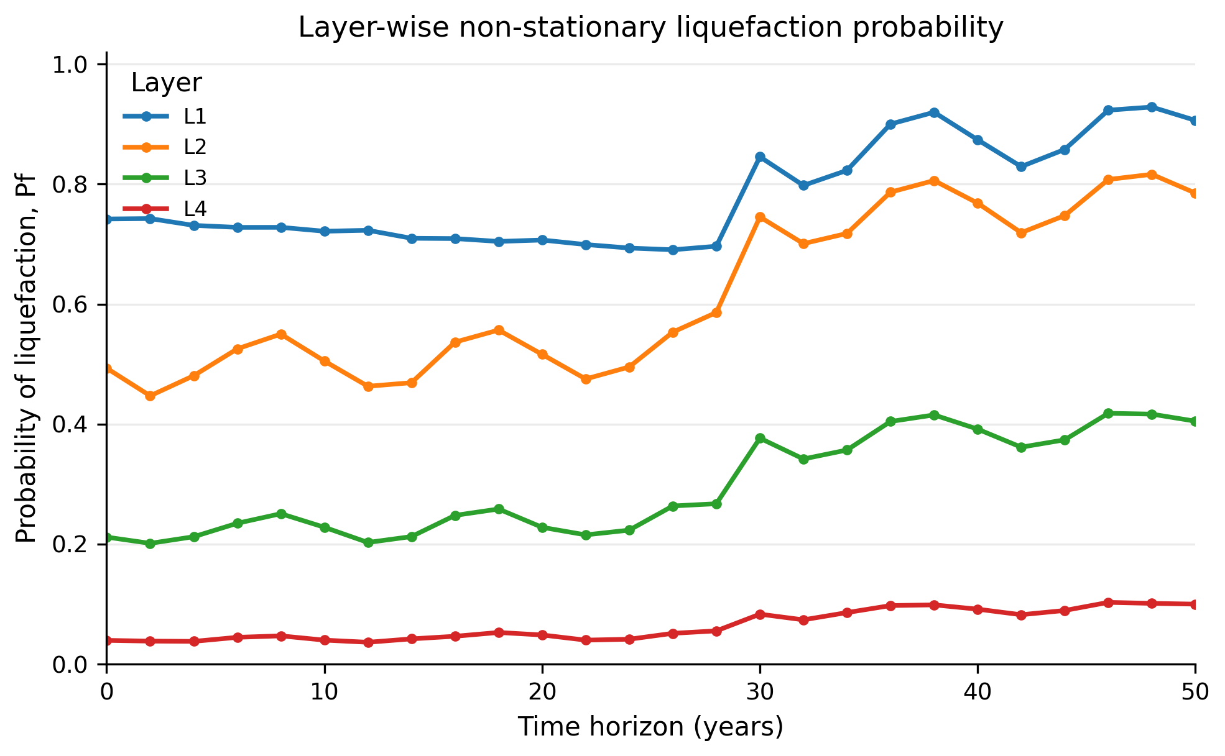
Fig. 1 Layer-wise non-stationary liquefaction probability for the extreme groundwater scenario with fines accumulation.
Fig. 2 summarises how the groundwater scenario, not only the layer, controls the profile-average probability. Fig. 3 presents a depth-time probability map that makes the shallow-layer concentration of risk visually explicit.
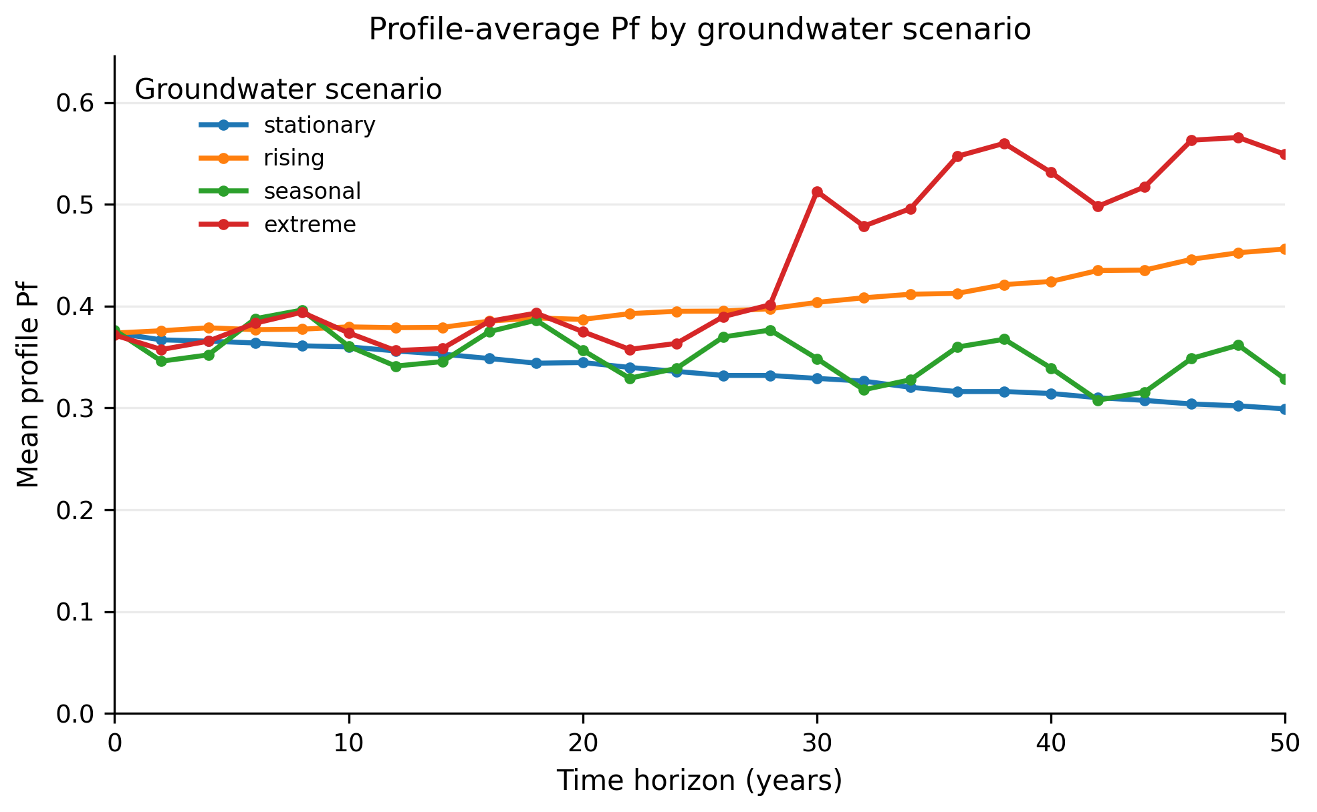
Fig. 2 Profile-average liquefaction probability by groundwater scenario for the fines-accumulation gradation case.
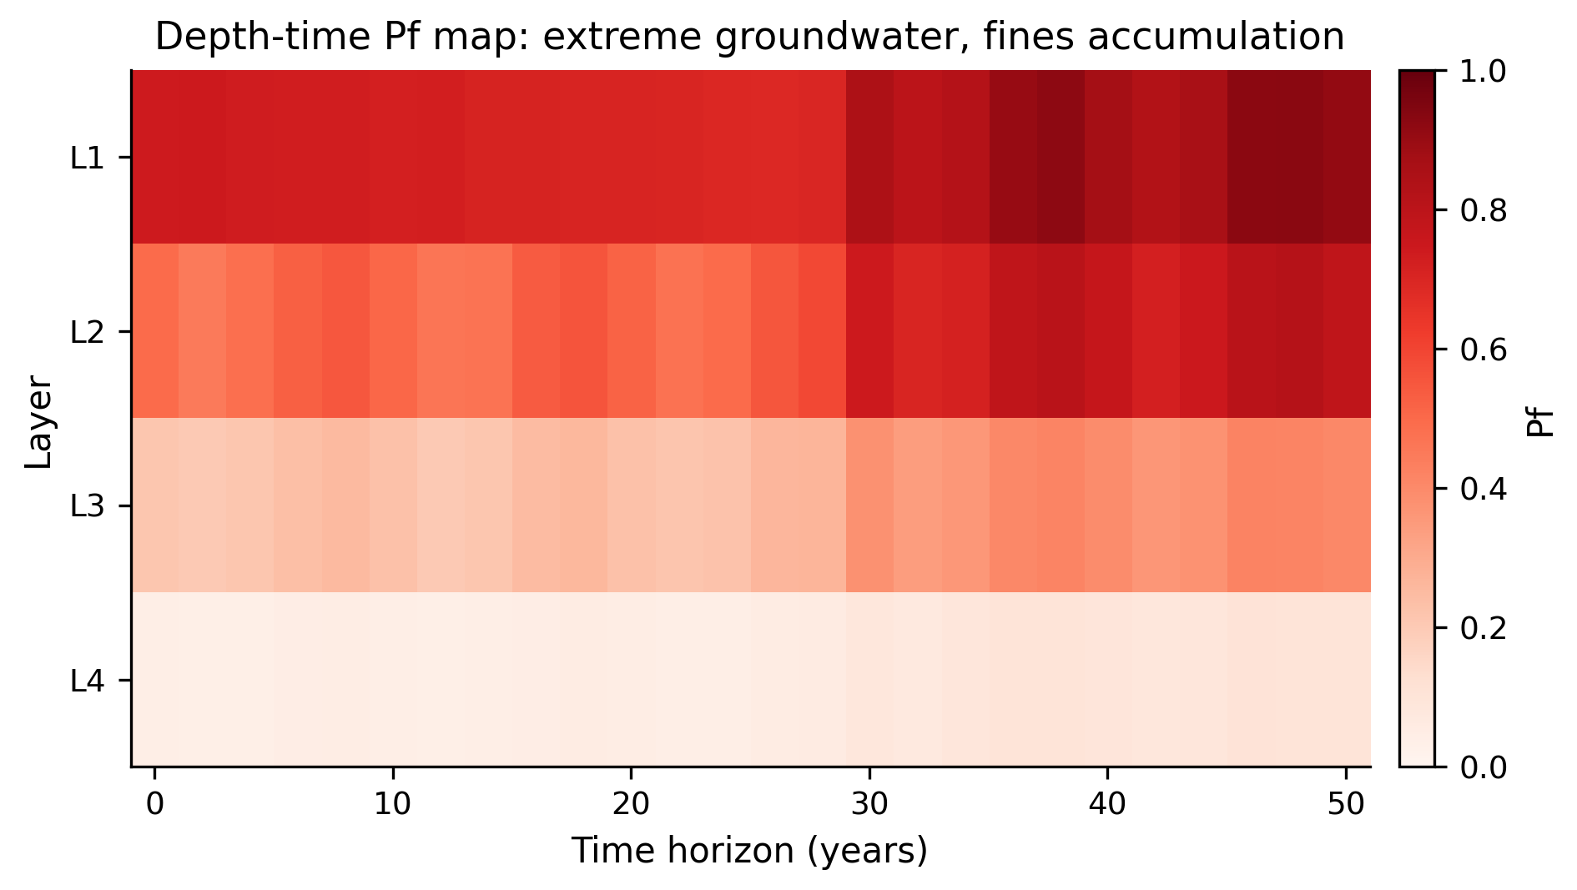
Fig. 3 Depth-time probability map for the extreme groundwater scenario with fines accumulation.
The main scenario-level outputs are summarised in Table 5. The extreme groundwater scenario is consistently the most severe. The largest maximum probability occurs under fines washout because the clean-sand-equivalent correction decreases when fines are removed, reducing the benchmark CRR. This result is not a universal physical claim; it is a transparent consequence of the selected empirical correction and is therefore reported as a sensitivity result rather than a field conclusion.
Table 5. Scenario-level summary of non-stationary liquefaction probability.
Groundwater | Gradation | Max Pf | Mean Pf | Max delta Pf | Final mean Pf | Min deterministic FS
extreme | fines_washout | 0.971 | 0.495 | 0.417 | 0.636 | 0.456
extreme | constant | 0.961 | 0.471 | 0.378 | 0.600 | 0.473
extreme | fines_accumulation | 0.929 | 0.440 | 0.314 | 0.549 | 0.549
rising | fines_washout | 0.885 | 0.467 | 0.347 | 0.573 | 0.624
rising | constant | 0.852 | 0.440 | 0.285 | 0.525 | 0.648
seasonal | fines_washout | 0.796 | 0.419 | 0.242 | 0.463 | 0.732
stationary | fines_washout | 0.788 | 0.401 | 0.108 | 0.430 | 0.732
rising | fines_accumulation | 0.765 | 0.403 | 0.167 | 0.456 | 0.756

A practical implication is that deterministic and stationary-probabilistic checks can understate the computed scenario-conditioned probability for selected states. Table 6 compares stationary and non-stationary profile-average screening indices at selected years for the extreme scenario and fines accumulation. The profile-average value is a compact diagnostic index, not the probability of system failure of the full soil column. The non-stationary estimate departs sharply after the extreme groundwater shift, which is precisely the behaviour that a state-dependent geohazard screening tool should reveal.
Table 6. Stationary versus non-stationary profile-average probabilities for the extreme/fines-accumulation case.
Year | Stationary Pf | Non-stationary Pf | Difference
0 | 0.375 | 0.372 | -0.003
10 | 0.372 | 0.375 | 0.003
20 | 0.372 | 0.377 | 0.004
30 | 0.373 | 0.513 | 0.140
40 | 0.373 | 0.534 | 0.161
50 | 0.373 | 0.551 | 0.178

5. Reproducibility controls and benchmark interpretation
The benchmark was designed so that a reviewer can inspect every transformation from input assumptions to reported probabilities. The script fixes the random seed, writes the layer profile to a separate CSV file, reports layer-time-scenario outputs, and stores profile-level comparisons in a separate table. This structure avoids a common weakness in methodological geotechnical papers: results are not only shown as final plots but can be traced back to the random variables, scenario definitions and intermediate quantities used to compute the limit state. The supplied files therefore support both replication and controlled modification of the benchmark.
A second control is the explicit comparison between stationary and non-stationary probabilities. The stationary calculation keeps groundwater and fines content at the initial state while still propagating resistance, demand and model uncertainty. The non-stationary calculation changes the scenario means before sampling. This separation is important because it isolates the effect of changing environmental and material state variables from ordinary Monte Carlo variability. It also allows the difference Delta Pf to be interpreted as a scenario effect rather than as a replacement for conventional reliability analysis.
A third control is the deterministic factor of safety reported alongside probability. The deterministic value is not treated as the decision metric, but it helps identify whether the probabilistic result is driven by a clearly unstable mean state or by uncertainty around a marginal state. In the most severe cases, the minimum deterministic factor of safety falls below one; in less severe cases, probability may still be non-negligible because uncertainty spreads the limit-state margin across the failure boundary. This combined reporting is useful for engineering review because it prevents the probability curve from becoming a black-box output.
The selected fines-content scenarios also serve as an internal sensitivity check. Fines accumulation and fines washout should not be read as universal physical trends. Their purpose is to test whether the workflow responds to a compositional variable that enters the clean-sand-equivalent resistance correction. The benchmark shows that a gradation pathway can change the relative severity of scenarios even when the groundwater path is unchanged. That observation is directly relevant to hydraulic fills, reclaimed land, erodible deposits and sites where internal instability or sediment migration is plausible.
For a geo-engineering audience, the most important interpretive point is that the benchmark produces a screening-oriented probability sequence, not only a triggering classification. A profile can be ranked by present-day factor of safety, by current computed probability, by maximum layer probability over the planning horizon, by final-state probability, by profile-average screening index, or by Delta Pf relative to a stationary assumption. These metrics answer different questions. Current Pf supports near-term screening; maximum layer Pf identifies the most critical stratum; final-state Pf supports long-term scenario comparison; and Delta Pf identifies cases where stationarity is particularly misleading. Reporting them together makes the method more useful for infrastructure risk screening than a single binary pass/fail classification, but none of these diagnostics should be read as a calibrated system-failure probability for the full profile.
The workflow also creates a path for future site-specific calibration. If monitoring data are available, groundwater-depth trajectories can be replaced by measured or forecasted time series. If gradation data are available, the fines-content model can be replaced by a transport or updating model. If local seismic hazard information is available, the PGA distribution can be conditioned on return period or on an event set. If CPT data are preferred, the resistance module can be replaced by a CPT-based triggering relation. The benchmark architecture therefore supports substitution of better evidence without changing the logic of the non-stationary reliability calculation.
The main limitation is that the present benchmark uses independent Monte Carlo sampling within each layer and does not model spatial correlation. This is conservative in some comparisons and unconservative in others, depending on how profile failure is defined. A random-field model would be needed to represent vertical correlation of resistance and fines content. Another limitation is that the benchmark uses a simplified stress-reduction coefficient and a smooth CRR approximation. This is acceptable for a methodological benchmark but not sufficient for final design. Site application should use a project-approved triggering model and should document the uncertainty model used for each empirical component.
The benchmark is therefore best understood as an auditable computational experiment. Its value lies in showing that, for the prescribed scenarios and selected triggering formulation, non-stationary state variables can substantially change computed probability trends within the benchmark assumptions and that this change can be quantified without hiding the assumptions. The results support considering non-stationary groundwater and gradation scenarios as screening diagnostics, pending site-specific calibration before project use.
Table 7 reports the reproducibility and interpretation controls used to audit the benchmark workflow.
Table 7. Reproducibility and interpretation controls used in the benchmark.
Control | Implementation | Reason for inclusion
Fixed seed | Random seed 1182026 | Allows replication of every Monte Carlo output
Separate input profile | synthetic_layer_profile.csv | Makes layer assumptions explicit
Stationary comparison | pf_stationary in the result file | Isolates the effect of non-stationary state variables
Deterministic companion metric | fs_deterministic_nonstationary | Connects probability results to familiar engineering checks
Scenario summary | liquefaction_benchmark_summary.csv | Supports screening by maximum, mean and final-horizon probability
Editable code and figures | Python script plus PNG/SVG figures | Allows reviewer reruns and figure regeneration
Table 7 is included to make the computational controls explicit. These checks are not cosmetic; they are the evidence that the benchmark can be rerun, interrogated and adapted without changing the manuscript narrative by hand.
Monte Carlo convergence and high-Pf stability were evaluated using approximate 95% binomial confidence intervals for each Pf estimate and repeated-sample checks for the most severe state. This check does not prove site validity, but it shows that the high Pf values are not a random-sampling artefact of the selected sample size.
Table 8 reports the Monte Carlo convergence check used to assess high-Pf stability for the most severe state.
Table 8. Monte Carlo convergence check for the most severe benchmark state.
Sample size | Replicates | Mean Pf | Std. Pf | Range
1000 | 5 | 0.9662 | 0.0126 | 0.9440-0.9750
3000 | 5 | 0.9643 | 0.0022 | 0.9627-0.9680
6000 | 5 | 0.9632 | 0.0018 | 0.9610-0.9653
12000 | 5 | 0.9627 | 0.0016 | 0.9608-0.9642
The convergence pattern in Table 8 supports the interpretation that the severe-state probability is driven by the scenario definition and layer properties, not by insufficient Monte Carlo sampling. The remaining scientific limitation is therefore not numerical instability, but the intentionally synthetic nature of the benchmark; this limitation is disclosed in the discussion and data statement.

5.1 External trend-consistency check
Because the benchmark is synthetic, an external consistency check is needed to reduce the chance that the paper is read as an isolated numerical exercise. The check used here is deliberately modest: it does not claim field calibration, but tests whether the model directions agree with published liquefaction knowledge. The first external anchor is that groundwater depth is a recognised driver of liquefaction probability. Holzer et al. [40] developed liquefaction probability curves for surficial geologic deposits and explicitly reported probabilities for a water table at 1.5 m under earthquake loading. Recent reviews of probabilistic urban liquefaction hazard also identify groundwater depth, saturated sandy layer thickness, soil susceptibility and shaking intensity as controlling inputs [45]. These external observations support the benchmark decision to treat groundwater as a time-dependent state variable rather than as a fixed site label.
The second external anchor is fines-content sensitivity. Fines content affects liquefaction triggering correlations and can change the clean-sand equivalent resistance used by simplified procedures. Site and method comparisons in the liquefaction literature show that fines content and plasticity assumptions can substantially alter liquefaction potential estimates [42, 39]. The benchmark therefore tests both fines accumulation and fines washout. These pathways should be interpreted as scenario variables linked to sedimentation, erosion, hydraulic fills, internal migration of particles and anthropogenic ground modification, not as universal predictions for all deposits.
The third external anchor is the need for probabilistic regional or infrastructure-scale screening. Current probabilistic liquefaction studies increasingly propagate uncertainty in subsurface conditions, groundwater, soil behaviour and model form for regional or distributed assets [43, 44]. The benchmark aligns with that direction by producing probability time series, uncertainty intervals and a profile-level comparison instead of a single deterministic pass/fail result. It remains simpler than a regional geostatistical model, but it is intentionally positioned as a reproducible intermediate benchmark for non-stationary risk screening.
Table 9 summarises the external consistency checks. The table is included before the broader discussion so that the reviewer can separate three ideas: the benchmark is synthetic, its trend directions are literature-consistent, and site-specific calibration remains necessary before project design use.
Table 9. External trend-consistency checks supporting the benchmark assumptions.
External observation | Representative source | Benchmark counterpart | Interpretation
Groundwater depth affects liquefaction probability | Holzer et al. (2011); Cruz et al. (2024) | Stationary, rising, seasonal and extreme zw(t) paths | Supports treating groundwater as a non-stationary state variable, without implying site calibration
Fines content changes triggering assessment | Lee et al. (2020); Yang and Wei (2024) | Constant, fines accumulation and fines washout scenarios | Supports gradation sensitivity, while preserving site-calibration caution
Probabilistic screening propagates subsurface uncertainty | Greenfield et al. (2024); USGS (2025) | Monte Carlo layer-time-scenario estimates with confidence intervals | Supports reporting Pf(t), confidence intervals and profile-level diagnostics as screening outputs
Infrastructure decisions require horizon-aware metrics | Kramer and Mayfield (2007); Phoon and Ching (2015) | Maximum, mean and final-horizon probabilities | Connects benchmark outputs to risk prioritisation

5.2 Global sensitivity and artefact control
A final diagnostic issue is whether the high probabilities in the extreme scenario are artefacts of the chosen parameterisation. To address this, the benchmark includes a rank-correlation sensitivity check over all layer-time-scenario records. The analysis is not presented as a substitute for a full variance-based sensitivity design; rather, it is a transparent diagnostic that identifies which reported state variables most strongly co-vary with the non-stationary probability of liquefaction. This addresses the methodological concern that the output might be dominated by a hidden numerical accident rather than by interpretable resistance and demand quantities.
Fig. 4 reports absolute Spearman rank correlations between Pf and the main benchmark variables. The strongest association is the deterministic factor-of-safety companion metric, followed by CRR, corrected penetration resistance, fines content and depth. This pattern is technically plausible: the probability output is controlled primarily by resistance margin and layer susceptibility, while groundwater depth enters through CSR and effective stress. Therefore, the high Pf values are not disconnected from the mechanics of the model; they occur where the deterministic margin, corrected resistance and shallow susceptible layers jointly place the simulated states near or beyond the limit-state boundary.
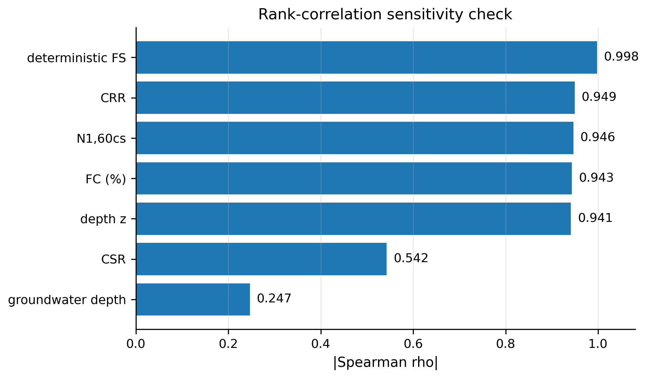
Fig. 4 Rank-correlation sensitivity check for non-stationary liquefaction probability.
Table 10 complements Figure 4 by reporting the numerical correlation values. The low direct rank association of groundwater depth should not be misread as groundwater being unimportant. In this benchmark, groundwater influence is partially mediated through CSR and through the scenario structure; depth, corrected resistance and fines content also vary strongly across layers. The sensitivity check therefore supports a nuanced interpretation: groundwater scenarios trigger temporal changes, while layer susceptibility controls where those changes become severe.
Table 10. Global sensitivity rank for non-stationary liquefaction probability.
Variable | Pearson with Pf | Spearman with Pf | Absolute Spearman
deterministic FS | -0.967 | -0.998 | 0.998
crr | -0.955 | -0.950 | 0.950
n1_60cs | -0.959 | -0.947 | 0.947
fc_pct | -0.946 | -0.944 | 0.944
z_mid_m | -0.950 | -0.941 | 0.941
csr | -0.580 | -0.543 | 0.543
gw_depth_m | -0.226 | -0.246 | 0.246
The combined diagnostics from confidence intervals, repeated-sample convergence, external trend checks and rank sensitivity show that the benchmark is reproducible, internally consistent and directionally plausible within its assumptions. It remains explicit about its synthetic status while providing computational diagnostics that allow readers to reproduce, criticise and extend the workflow.

5.3 External case-history sanity check
Because the benchmark is synthetic, an external trend-consistency check was added using the open case-history dataset of Hu et al. [41], which compiles 234 gravelly-soil liquefaction and non-liquefaction cases from 17 earthquakes. The check is deliberately modest: it does not calibrate the proposed benchmark to a field site, and it does not claim that gravelly-soil behaviour is identical to the synthetic sand-profile example. Instead, it tests whether demand, resistance and groundwater indicators rank historical liquefied cases above non-liquefied cases in the expected direction. The external case-history analysis is therefore used only as an independent trend-consistency and discrimination check. It is not intended as site-specific calibration, nor as formal evidence for a new liquefaction triggering model.
Fig. 5 reports the rank-discrimination performance of the external sanity check. A combined demand-resistance-groundwater score achieved an AUC of 0.811, while the Vs-based and DPT-based scores achieved AUC values of 0.796 and 0.778, respectively. These values are not presented as a new prediction model. They show that the same classes of variables used in the non-stationary benchmark demand, resistance and groundwater position have a directionally consistent relationship in an independent published case-history dataset.

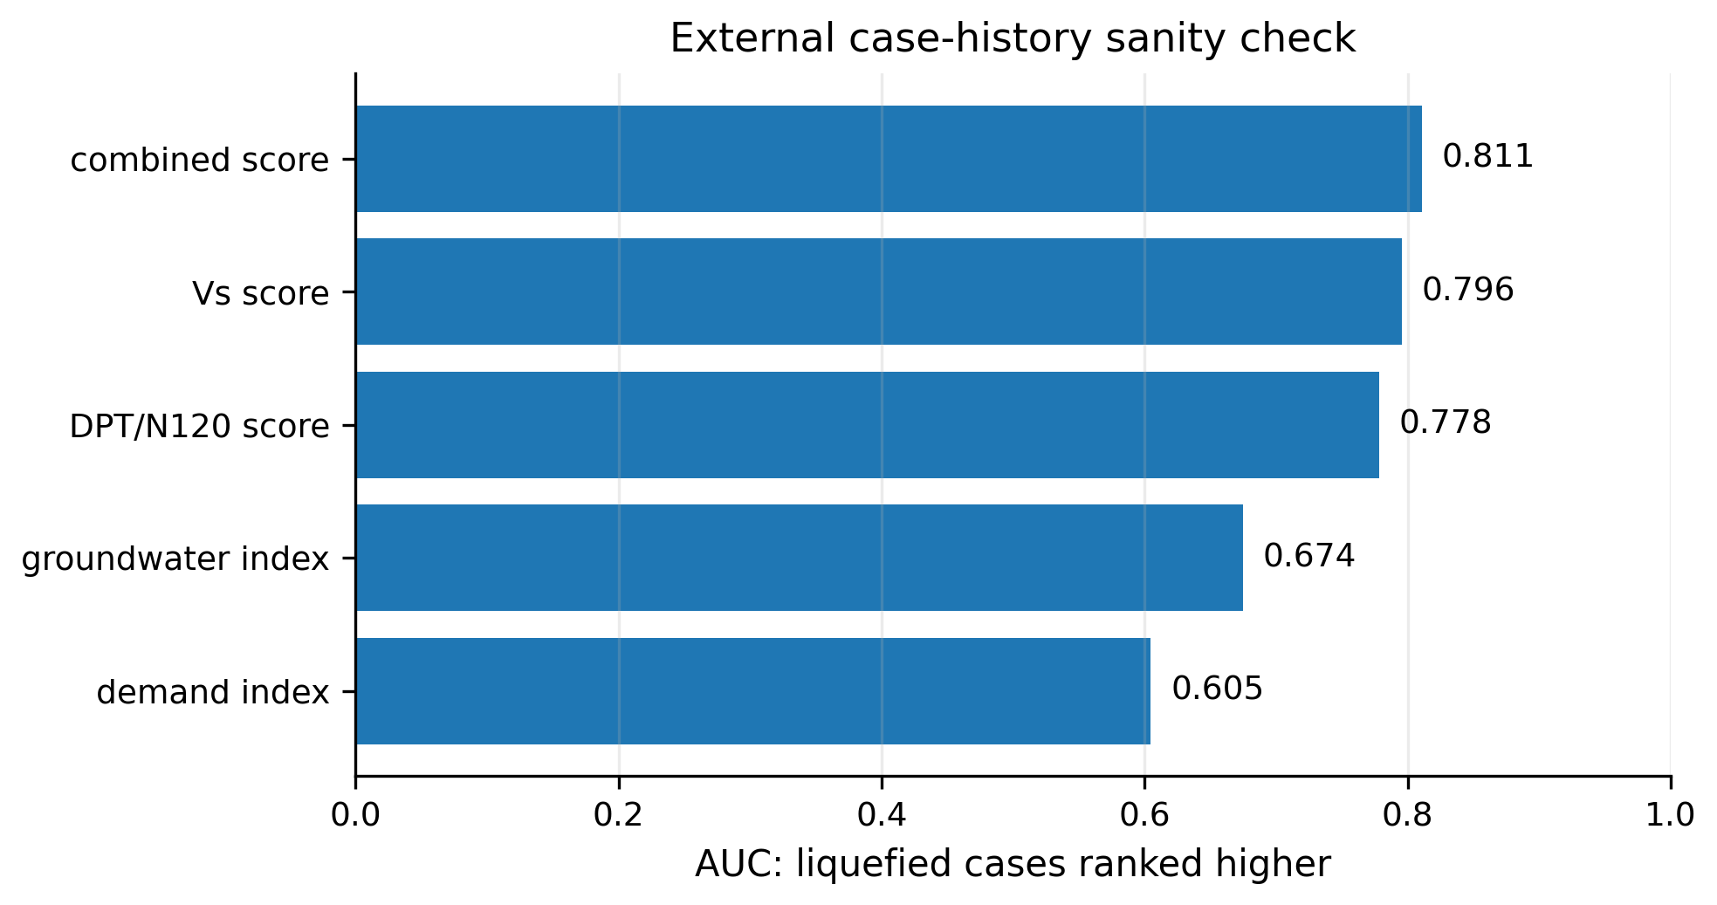
Fig. 5 External case-history sanity check using the Hu et al. [41] gravelly-soil liquefaction dataset.
Table 11 reports the numerical summary of the same external check. Liquefied cases have higher mean and median screening scores than non-liquefied cases for the combined, DPT-based and Vs-based indices. The demand-only and groundwater-only components are weaker on their own, which is expected because liquefaction triggering is not controlled by a single variable. This result supports the interpretation that the external comparison is an auditable secondary check supplied with the code and CSV outputs.
Table 11. External case-history sanity-check summary.
The external check was extended beyond rank AUC by adding five-fold calibrated Brier scores, probability-calibration bins and transparent confusion-matrix diagnostics. A static proxy version of the benchmark limit-state was also applied to the Hu et al. cases where CSR, resistance and fines-content data were available. These Hu et al. and Wenchuan analyses are retained as external case-history compatibility checks: they evaluate whether demand, resistance and groundwater indicators rank observed liquefied cases above non-liquefied cases, but they do not constitute a calibrated non-stationary field application.
Detailed external discrimination, five-fold calibration and static compatibility diagnostics are reported in Table 12A and Table 15A. Their role is external compatibility, not site-calibrated validation of the synthetic benchmark.
Check | n | Liq. | Non-liq. | Mean liq. | Mean non-liq. | Median liq. | AUC
Combined score | 234 | 136 | 98 | 0.250 | -0.347 | 0.243 | 0.811
DPT/N120 score | 234 | 136 | 98 | 0.219 | -0.304 | 0.124 | 0.778
Vs score | 234 | 136 | 98 | 0.237 | -0.328 | 0.207 | 0.796
Demand index | 234 | 136 | 98 | 0.132 | -0.183 | -0.095 | 0.605
Groundwater index | 234 | 136 | 98 | 0.243 | -0.337 | 0.496 | 0.674

The standard SPT model-form comparison is reported in Table 13A. In the reproducibility package, the BI14 SPT curve is computed through liquepy when available. The same output files also report a BI14 median-parameter variant, FS scale ratios, and an explicit availability table for BI16, Cetin, Moss/CPT and Kayen/Vs alternatives so that unavailable exact methods are not silently renamed or substituted.

5.4 Site-calibrated extension and out-of-sample stress test
A documented-site extension was added using the DesignSafe PRJ-3758 Nisqually CPT case-history dataset. The extension normalises 24 CPT workbooks and Summary Table S1 into site-profile, groundwater, gradation-status and event-observation CSV files. The groundwater module fits a trajectory with trend, annual sine/cosine terms and an event indicator, and Fig. 6 reports observed water-table points, the fitted mean curve, a 95% interval and the 28 February 2001 earthquake date. Because PRJ-3758 does not include repeated FC/D50 measurements, the gradation module is explicitly marked as baseline uncertainty/proxy information rather than calibrated temporal gradation evolution.
The validation protocol is intentionally out-of-sample. The primary Nisqually protocol uses leave-one-site-family-out spatial validation, pools the held-out predictions, and reports calibration diagnostics on those predictions. Under this protocol, M2 (nonstationary groundwater plus gradation proxy) improves Brier score relative to M0 (static stationary), from 0.072 to 0.026 in pooled predictions and from 0.088 to 0.025 as mean fold Brier. Calibration remains imperfect because the dataset is small and strongly separable; calibration slopes are reported explicitly rather than hidden. Exhaustive paired-family and strict SODO+UW holdouts are retained as sensitivity checks; the paired-family protocol also favours M2, while the single SODO+UW split does not. Fig. 7 visualizes the out-of-sample Brier comparison, and Fig. 8 reports the vertical variogram diagnostic used by the random-field extension.
The Canterbury temporal extension adds a second documented-site application using DesignSafe PRJ-2937, 100 Osbourne St CPT01. The same CPT profile is evaluated for the 2010 Darfield, 2011 Christchurch and 2016 Valentine earthquake states using event-specific Mw, PGA, groundwater depth and manifestation codes. A transfer model trained on the Nisqually case histories is applied to the three-event sequence. Because only three event states are available for that CPT, this is treated as a minimal temporal site application rather than a large-sample validation; nevertheless, it directly shows that event time and observed groundwater/PGA states modify Pf(t) using documented field data. In this temporal transfer, M2 lowers Brier score relative to M0 from 0.326 to 0.306, and M3 lowers it to 0.146. Fig. 9 visualizes the resulting Pf(t) curves across the documented event states.

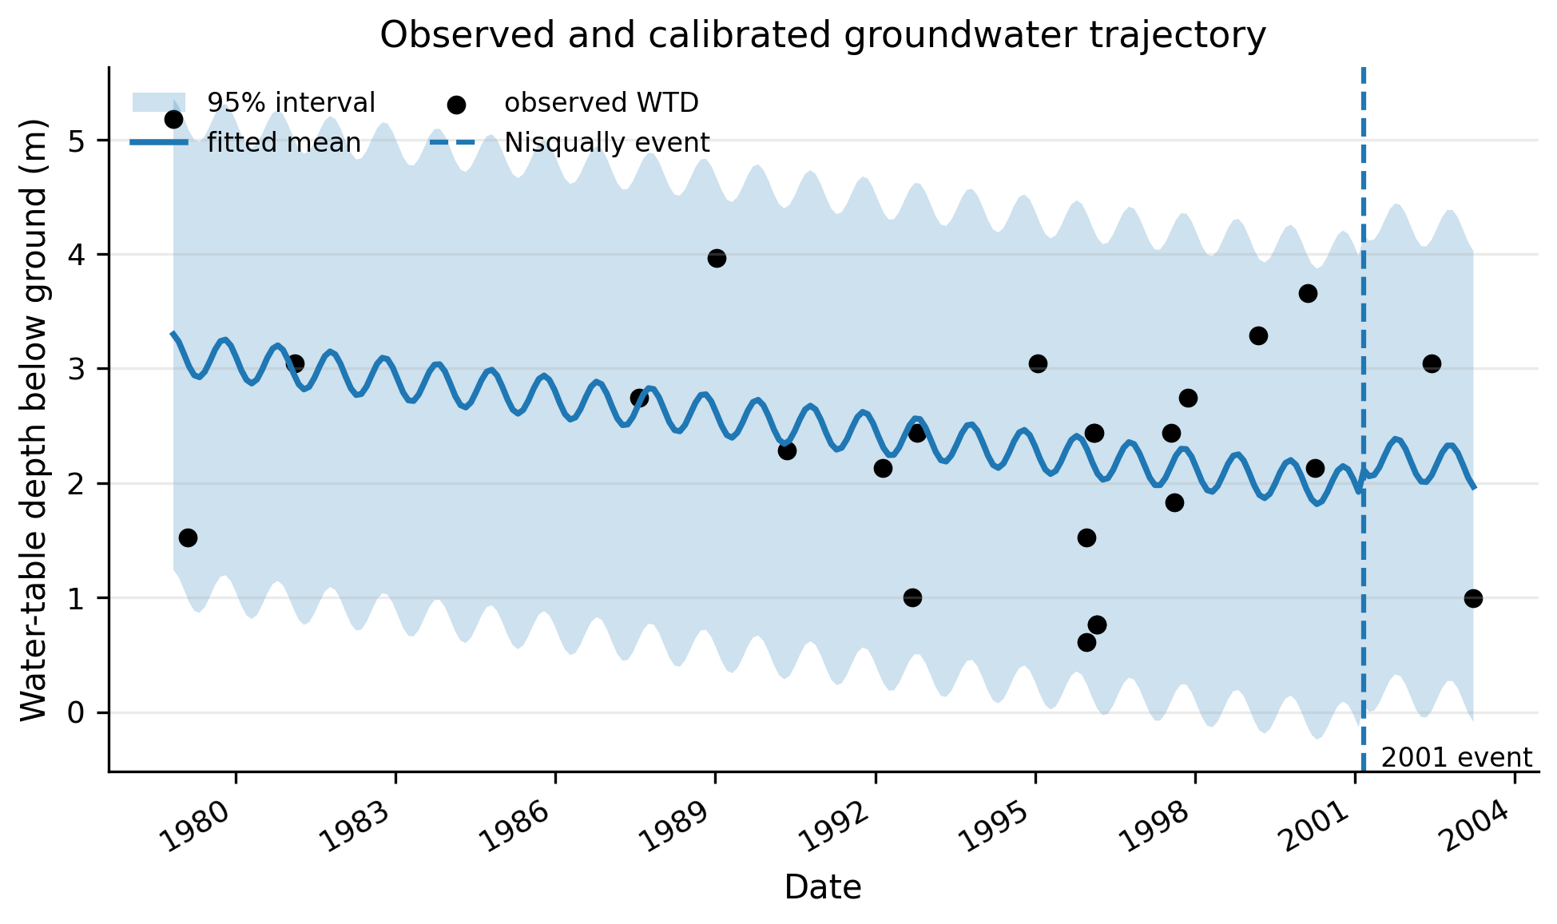
Fig. 6 Observed and calibrated groundwater trajectory for the Nisqually PRJ-3758 CPT case-history dataset. Points are reported water-table-depth observations, the line is the fitted mean trajectory, the band is the 95% interval and the vertical line marks the 28 February 2001 earthquake.

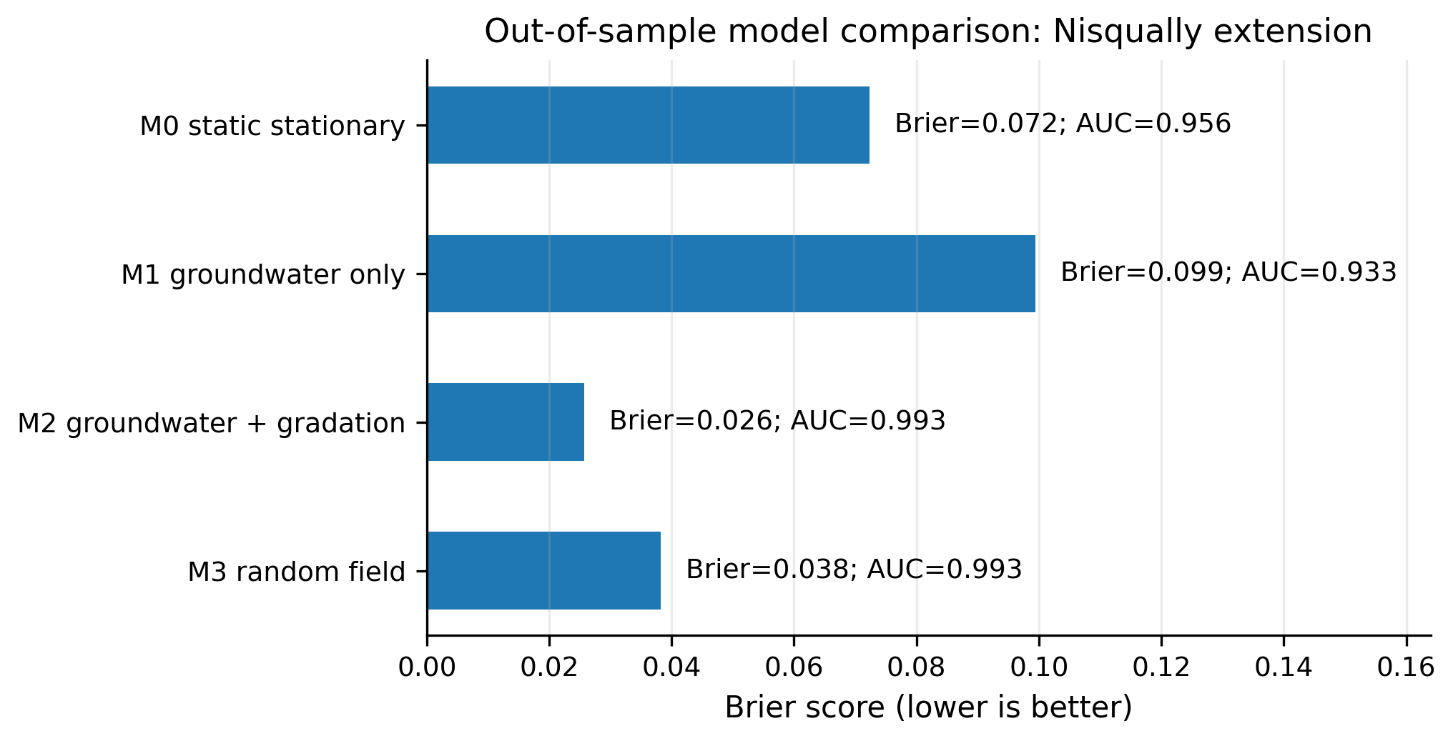
Fig. 7 Out-of-sample M0-M3 Brier comparison for the Nisqually site-calibrated extension. Primary metrics use leave-one-site-family-out spatial validation.

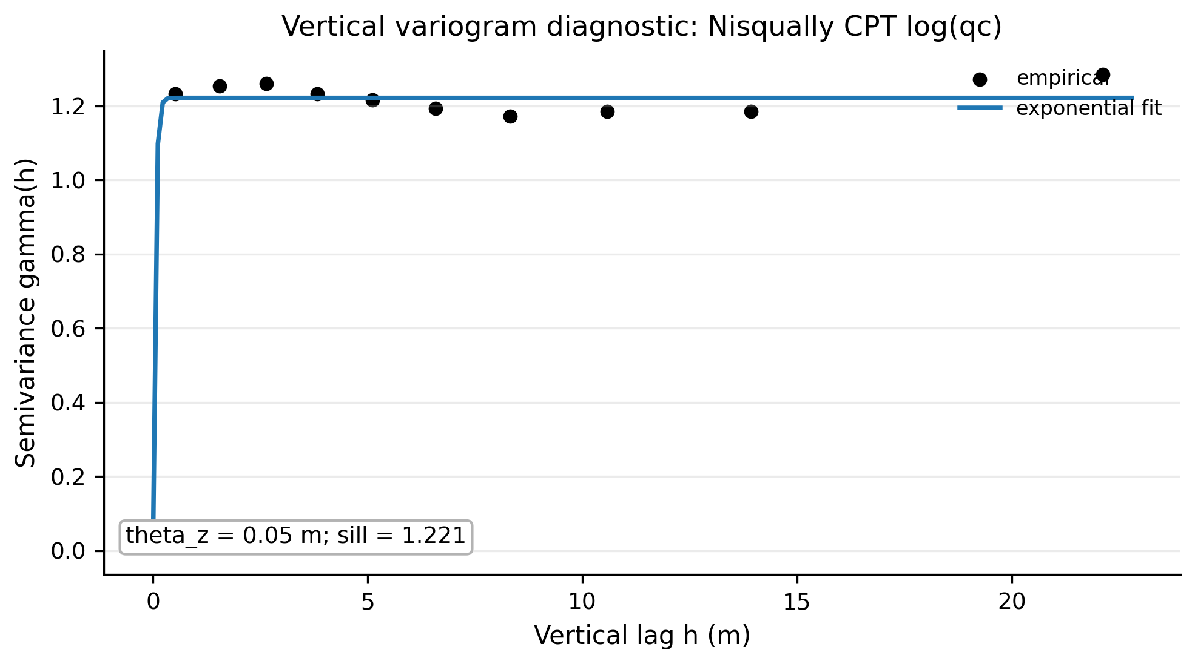
Fig. 8 Empirical and fitted vertical variogram for the Nisqually CPT log(qc) diagnostic used by the random-field extension.

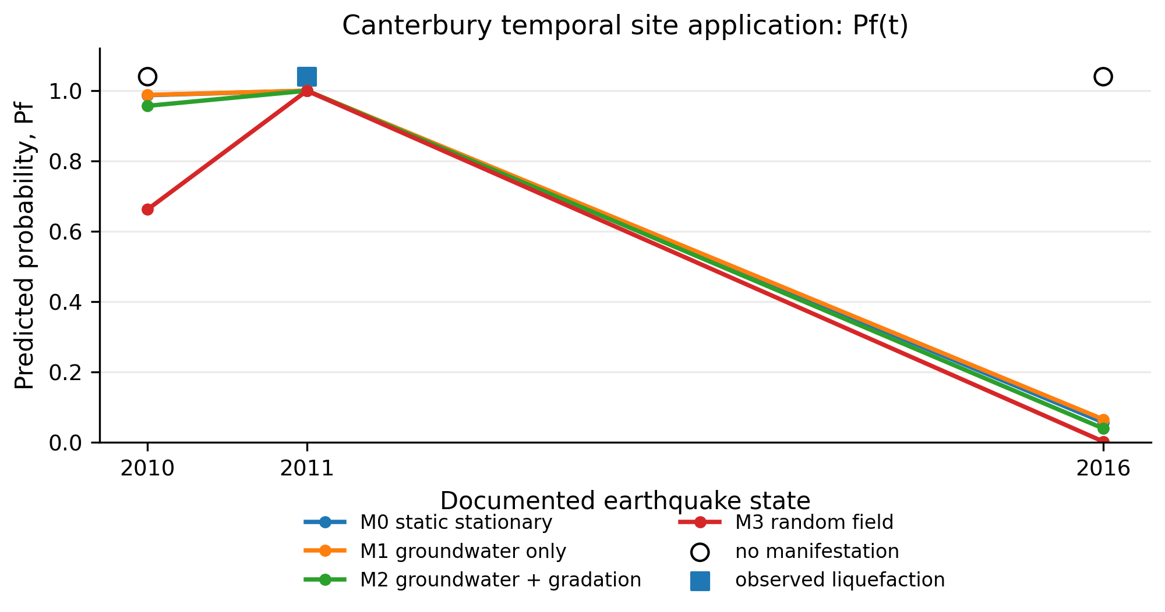
Fig. 9 Canterbury 100 Osbourne CPT01 temporal site application. The curves show Pf(t) over the 2010, 2011 and 2016 documented earthquake states; the red marker indicates the observed manifestation event.

5.5 Physical interpretation of gradation-evolution scenarios
The gradation scenarios should be read as prescribed physical states rather than as a stand-alone sediment-transport model. The fines-accumulation path represents mechanisms such as sedimentation, hydraulic fill placement, internal particle migration toward a layer, clogging or progressive inclusion of finer material. The fines-washout path represents erosion, seepage-driven migration, loss of fines during extreme hydraulic gradients or disturbance of a loose deposit. The constant-gradation path is the neutral baseline against which these perturbations are compared.
This interpretation limits the claim to what the benchmark actually computes. The paper does not predict future gradation evolution from first principles; it evaluates how a plausible prescribed evolution, if inferred from monitoring, maintenance history or site interpretation, changes liquefaction probability through the clean-sand equivalent resistance and the demand-resistance margin. This framing is important because it keeps the contribution in the domain of reliability screening and scenario analysis, while leaving site-specific transport or erosion calibration as a later task.

6. Discussion
The BI14-style comparison produced high rank agreement across scenario-gradation groups, with Spearman correlations between 0.931 and 0.997. The absolute probability scale differs because the resistance curve and probability mapping differ from the benchmark module, but the scenario and layer ordering remain largely stable. The external Hu et al. check adds discrimination and calibration diagnostics: the combined score reached AUC = 0.811 and five-fold Brier score = 0.172, while the static limit-state proxy reached AUC = 0.760 on 195 cases. These results strengthen compatibility evidence without converting the synthetic benchmark into a site-calibrated model.
The benchmark supports three technical observations for the prescribed scenarios and selected triggering formulation. First, groundwater non-stationarity changes both the mean computed probability level and the timing of computed probability escalation. In the extreme scenario, a discrete groundwater shift produces a visible probability jump after year 30. Second, prescribed gradation evolution can alter the resistance side of the triggering calculation in a direction that depends on the adopted correction model. Third, the profile-average probability is not simply the shallowest-layer probability; it is a compact screening index that should be interpreted together with maximum-layer probability, layer-wise plots and depth-time maps, and not as a physical probability of system failure for the full profile.
For transparency, the supplementary profile comparison file also reports system-level diagnostic summaries derived from the same layer probabilities. If profile failure is defined as liquefaction in at least one layer, a system metric requires an explicit dependence model among layers. Under independent layer events, Psys_ind(t) = 1 - product_i[1 - Pf_i(t)]; under arbitrary dependence, Frechet bounds are max_i Pf_i(t) <= Psys(t) <= min(1, sum_i Pf_i(t)). For example, in the extreme/fines-accumulation case at year 50, the profile-average screening index is 0.549, the maximum layer Pf is 0.906, Psys_ind is 0.989, and the Frechet bounds are 0.906-1.000. These values are reported as diagnostics only, because the benchmark does not define a calibrated vertical correlation model. A Gaussian-copula vertical-dependence sensitivity was added to the supplement to bracket how system-level diagnostics change under equicorrelation values from 0.0 to 0.9; this remains a dependence diagnostic rather than a calibrated random-field model.
The results also clarify the limits of the proposed workflow. The benchmark does not claim that a specific site will experience the reported probabilities. It does not calibrate a groundwater model, a gradation transport model or a site-specific liquefaction triggering curve. Instead, it provides an auditable scaffold into which site monitoring, hydrologic forecasts, laboratory gradation data or updated CPT/SPT data can be inserted. That distinction defines the scope of the contribution: the paper is a reproducible geo-engineering benchmark, not a disguised site case study.
The method can be extended in several ways. A random-field representation could replace independent layer sampling; Bayesian updating could assimilate monitoring data; subset simulation or importance sampling could reduce variance for rare probabilities; and decision thresholds could be linked to mitigation cost. These extensions are consistent with reliability practice and are intentionally left modular rather than embedded in a closed black-box model.

7. Conclusions
This paper frames liquefaction assessment within a non-stationary reliability setting in which groundwater depth and gradation are time-dependent state variables. The proposed framework converts a conventional triggering check into Pf(z,t), allowing layers and horizons to be compared under stationary, rising, seasonal and extreme groundwater conditions. The key contribution is the reproducible workflow: every benchmark input, output table, figure and script is supplied, making the calculation auditable and adjustable.
The synthetic benchmark shows that a stationary assessment can miss computed scenario-conditioned probability escalation when groundwater conditions evolve within the benchmark assumptions. For the tested profile, the extreme groundwater scenario generated the largest probabilities, with shallow layers reaching high Pf values after the imposed groundwater shift. Prescribed gradation change also influenced the resistance term and altered the relative severity of scenarios. These findings support considering non-stationary probability curves and depth-time maps as screening diagnostics for sites that may become more vulnerable during their service life, pending site-specific calibration before design or prioritisation decisions.
The framework should be used with caution. The numerical values reported for the synthetic profile are benchmark values, not calibrated site predictions. For this reason, the supplementary package now separates two products: the reproducible synthetic benchmark and a site-calibrated Nisqually extension using DesignSafe PRJ-3758 CPT case histories. The site extension includes measured CPT profiles, coordinates, CPT dates, reported water-table depth, conditional PGA and observed manifestation, but the downloaded case-history files do not report repeated FC/D50 laboratory gradation histories. Therefore, gradation is treated as baseline uncertainty or CPT-derived proxy information, and the synthetic fines-accumulation/fines-washout paths remain sensitivity scenarios rather than validated site predictions.

Acknowledgements
The author thanks the Universidad de Panama for the academic environment supporting this methodological work.

Competing interests
The author declares no competing interests.

Funding
No specific funding was received for this work.

Supplementary material
The supplementary files are supplied as Online Resource 1 and include CSV inputs, generated outputs, scripts, README, requirements and regenerated figures. The same supplementary material is also available in the versioned GitHub release: https://github.com/gabrielmontufar/article-118-nonstationary-liquefaction-benchmark/releases/tag/v1.5-site-validation-loo.

Data availability
The benchmark data, source code, figures and README are provided as Online Resource 1 and in the public GitHub repository: https://github.com/gabrielmontufar/article-118-nonstationary-liquefaction-benchmark. The versioned release used for this submission is available at: https://github.com/gabrielmontufar/article-118-nonstationary-liquefaction-benchmark/releases/tag/v1.5-site-validation-loo. The synthetic benchmark script is self-contained. The site-extension scripts use public DesignSafe source files downloaded separately because the raw datasets are large: Nisqually PRJ-3758 (10.17603/ds2-nsf8-7944) and Canterbury PRJ-2937. Normalized CSV inputs and all generated outputs used in the manuscript are included in Online Resource 1; rerunning raw extraction requires placing the public DesignSafe files in the paths stated in the scripts or editing those paths to the local download location.

Author contributions
Gabriel J. Montufar Chiriboga: conceptualization, methodology, software, formal analysis, verification, reproducibility checks, external trend-consistency assessment, investigation, writing, visualization and manuscript preparation.

Declaration of generative AI and AI-assisted technologies
Generative artificial intelligence tools were used to support language editing, organization and formatting. The author reviewed, verified and takes responsibility for the scientific results and final manuscript.

References
[1] Ang, A. H.-S., and Tang, W. H. 2007. Probability Concepts in Engineering: Emphasis on Applications to Civil and Environmental Engineering. 2nd ed. Hoboken, NJ: Wiley.
[2] Baecher, G. B., and Christian, J. T. 2003. Reliability and Statistics in Geotechnical Engineering. Chichester: Wiley.
[3] Benjamin, J. R., and Cornell, C. A. 1970. Probability, Statistics, and Decision for Civil Engineers. New York: McGraw-Hill.
[4] Boulanger, R. W., and Idriss, I. M. 2014. CPT and SPT Based Liquefaction Triggering Procedures. Report UCD/CGM-14/01. Davis, CA: Center for Geotechnical Modeling, University of California, Davis.
[5] Cetin, K. O., Seed, R. B., Der Kiureghian, A., Tokimatsu, K., Harder, L. F., Kayen, R. E., and Moss, R. E. S. 2004. Standard Penetration Test-Based Probabilistic and Deterministic Assessment of Seismic Soil Liquefaction Potential. Journal of Geotechnical and Geoenvironmental Engineering 130 (12): 1314-1340.
[6] Ching, J., and Phoon, K. K. 2014. Transformations and Correlations among Some Clay Parameters: The Global Database. Canadian Geotechnical Journal 51 (6): 663-685.
[7] Der Kiureghian, A. 2005. First- and Second-Order Reliability Methods. In Engineering Design Reliability Handbook, edited by E. Nikolaidis, D. M. Ghiocel, and S. Singhal. Boca Raton, FL: CRC Press.
[8] Ditlevsen, O., and Madsen, H. O. 1996. Structural Reliability Methods. Chichester: Wiley.
[9] Fenton, G. A., and Griffiths, D. V. 2008. Risk Assessment in Geotechnical Engineering. Hoboken, NJ: Wiley.
[10] Fredlund, D. G., and Rahardjo, H. 1993. Soil Mechanics for Unsaturated Soils. New York: Wiley.
[11] Fredlund, D. G., Rahardjo, H., and Fredlund, M. D. 2012. Unsaturated Soil Mechanics in Engineering Practice. Hoboken, NJ: Wiley.
[12] Idriss, I. M., and Boulanger, R. W. 2008. Soil Liquefaction during Earthquakes. Oakland, CA: Earthquake Engineering Research Institute.
[13] IPCC. 2021. Climate Change 2021: The Physical Science Basis. Cambridge: Cambridge University Press.
[14] Ishihara, K. 1993. Liquefaction and Flow Failure during Earthquakes. Geotechnique 43 (3): 351-451.
[15] Juang, C. H., Fang, S. Y., and Khor, E. H. 2006. First-Order Reliability Method for Probabilistic Liquefaction Triggering Analysis. Journal of Geotechnical and Geoenvironmental Engineering 132 (3): 337-350.
[16] Kayen, R., Moss, R. E. S., Thompson, E. M., Seed, R. B., Cetin, K. O., Der Kiureghian, A., Tanaka, Y., and Tokimatsu, K. 2013. Shear-Wave Velocity-Based Probabilistic and Deterministic Assessment of Seismic Soil Liquefaction Potential. Journal of Geotechnical and Geoenvironmental Engineering 139 (3): 407-419.
[17] Kenney, T. C., and Lau, D. 1985. Internal Stability of Granular Filters. Canadian Geotechnical Journal 22 (2): 215-225.
[18] Kramer, S. L. 1996. Geotechnical Earthquake Engineering. Upper Saddle River, NJ: Prentice Hall.
[19] Kramer, S. L., and Mayfield, R. T. 2007. Return Period of Soil Liquefaction. Journal of Geotechnical and Geoenvironmental Engineering 133 (7): 802-813.
[20] Lacasse, S., and Nadim, F. 1996. Uncertainties in Characterising Soil Properties. In Uncertainty in the Geologic Environment: From Theory to Practice, 49-75. Reston, VA: ASCE.
[21] Lu, N., and Likos, W. J. 2004. Unsaturated Soil Mechanics. Hoboken, NJ: Wiley.
[22] Melchers, R. E., and Beck, A. T. 2018. Structural Reliability Analysis and Prediction. 3rd ed. Hoboken, NJ: Wiley.
[23] Milly, P. C. D., Betancourt, J., Falkenmark, M., Hirsch, R. M., Kundzewicz, Z. W., Lettenmaier, D. P., and Stouffer, R. J. 2008. Stationarity Is Dead: Whither Water Management Science 319 (5863): 573-574.
[24] Moss, R. E. S., Seed, R. B., Kayen, R. E., Stewart, J. P., Der Kiureghian, A., and Cetin, K. O. 2006. CPT-Based Probabilistic and Deterministic Assessment of In Situ Seismic Soil Liquefaction Potential. Journal of Geotechnical and Geoenvironmental Engineering 132 (8): 1032-1051.
[25] Phoon, K. K., and Kulhawy, F. H. 1999. Characterization of Geotechnical Variability. Canadian Geotechnical Journal 36 (4): 612-624.
[26] Phoon, K. K., and Ching, J., eds. 2015. Risk and Reliability in Geotechnical Engineering. Boca Raton, FL: CRC Press.
[27] Rackwitz, R. 2000. Reviewing Probabilistic Soils Modelling. Computers and Geotechnics 26 (3-4): 199-223.
[28] Robertson, P. K., and Wride, C. E. 1998. Evaluating Cyclic Liquefaction Potential Using the Cone Penetration Test. Canadian Geotechnical Journal 35 (3): 442-459.
[29] Robertson, P. K. 2009. Interpretation of Cone Penetration Tests: A Unified Approach. Canadian Geotechnical Journal 46 (11): 1337-1355.
[30] Rubinstein, R. Y., and Kroese, D. P. 2016. Simulation and the Monte Carlo Method. 3rd ed. Hoboken, NJ: Wiley.
[31] Saltelli, A., Ratto, M., Andres, T., Campolongo, F., Cariboni, J., Saisana, M., and Tarantola, S. 2008. Global Sensitivity Analysis: The Primer. Chichester: Wiley.
[32] Seed, H. B., and Idriss, I. M. 1971. Simplified Procedure for Evaluating Soil Liquefaction Potential. Journal of the Soil Mechanics and Foundations Division 97 (9): 1249-1273.
[33] Seed, H. B., Tokimatsu, K., Harder, L. F., and Chung, R. M. 1985. Influence of SPT Procedures in Soil Liquefaction Resistance Evaluations. Journal of Geotechnical Engineering 111 (12): 1425-1445.
[34] Skempton, A. W., and Brogan, J. M. 1994. Experiments on Piping in Sandy Gravels. Geotechnique 44 (3): 449-460.
[35] Sobol, I. M. 2001. Global Sensitivity Indices for Nonlinear Mathematical Models and Their Monte Carlo Estimates. Mathematics and Computers in Simulation 55 (1-3): 271-280.
[36] Vanmarcke, E. H. 1977. Probabilistic Modeling of Soil Profiles. Journal of the Geotechnical Engineering Division 103 (11): 1227-1246.
[37] Wan, C. F., and Fell, R. 2008. Assessing the Potential of Internal Instability and Suffusion in Embankment Dams and Their Foundations. Journal of Geotechnical and Geoenvironmental Engineering 134 (3): 401-407.
[38] Youd, T. L., Idriss, I. M., Andrus, R. D., Arango, I., Castro, G., Christian, J. T., Dobry, R., Finn, W. D. L., Harder, L. F., Hynes, M. E., Ishihara, K., Koester, J. P., Liao, S. S. C., Marcuson, W. F., Martin, G. R., Mitchell, J. K., Moriwaki, Y., Power, M. S., Robertson, P. K., Seed, R. B., and Stokoe, K. H. 2001. Liquefaction Resistance of Soils: Summary Report from the 1996 NCEER and 1998 NCEER/NSF Workshops. Journal of Geotechnical and Geoenvironmental Engineering 127 (10): 817-833.
[39] Yang, Y., and Wei, Y. 2024. A New Shear Wave Velocity-Based Liquefaction Probability Model Using Logistic Regression: Emphasizing Fines Content Optimization. Applied Sciences 14 (15): 6793. https://doi.org/10.3390/app14156793.
[40] Holzer, T. L., Noce, T. E., and Bennett, M. J. 2011. Liquefaction Probability Curves for Surficial Geologic Deposits. Environmental & Engineering Geoscience 17 (1): 1-21.
[41] Hu, J., Wang, J., Zou, W., and Yang, B. 2021. Datasets for Gravelly Soil Liquefaction Case Histories. Data in Brief 36: 107104. https://doi.org/10.1016/j.dib.2021.107104
[42] Lee, J., Choi, C., and Kim, M. M. 2020. Estimation of Liquefaction Potential in Eco-Delta City (Busan) Using Different Approaches with Effect of Fines Content. International Journal of Geo-Engineering 11: 14.
[43] Greenfield, M. W., Estep, T. M., Taing, J., and Hitchcock, C. 2024. A Probabilistic Extension of Existing Site-Specific Liquefaction Triggering and Liquefaction Manifestation Methods for Regional Scale Evaluations. Soil Dynamics and Earthquake Engineering 182: 108711. https://doi.org/10.1016/j.soildyn.2024.108711.
[44] USGS. 2025. Regional Probabilistic Liquefaction Hazard Mapping for the Sacramento-San Joaquin River Delta. Final Technical Report G21AP10019. Reston, VA: U.S. Geological Survey.
[45] Cruz, A., Karimzadeh, S., Chieffo, N., Sandoval, E., and Lourenco, P. B. 2024. A Review of Probabilistic Approaches for Assessing the Liquefaction Hazard in Urban Areas. Archives of Computational Methods in Engineering 31 (8): 4673-4708. https://doi.org/10.1007/s11831-024-10124-4.
[46] Makdisi, A. J., and Kramer, S. L. 2024. Improved Computational Methods for Probabilistic Liquefaction Hazard Analysis. Soil Dynamics and Earthquake Engineering 176: 108272. https://doi.org/10.1016/j.soildyn.2023.108272.
[47] Ordaz, M., Salgado-Galvez, M. A., Manica, M. A., Ovando-Shelley, E., Faccioli, E., Osorio, L., and Madrigal, M. C. 2023. Event-Based Probabilistic Liquefaction Hazard Analysis for Defining Soil Acceptance Criteria. Soil Dynamics and Earthquake Engineering 166: 107781. https://doi.org/10.1016/j.soildyn.2023.107781.
[48] Olaya, F., Bray, J. D., and Abrahamson, N. 2024. Performance-Based Probabilistic Liquefaction-Induced Ground Settlement Procedure. Earthquake Spectra 40 (2): 1301-1323. https://doi.org/10.1177/87552930241234289.
[49] Javanbakht, A., Molnar, S., Sadrekarimi, A., and Adhikari, S. R. 2025. Performance-Based Liquefaction Analysis and Probabilistic Liquefaction Hazard Mapping Using CPT Data within the Fraser River Delta, Canada. Soil Dynamics and Earthquake Engineering 189: 109101. https://doi.org/10.1016/j.soildyn.2024.109101.
[50] Global Earthquake Model Foundation. 2024. OpenQuake Engine 3.20.1 Documentation: Liquefaction Inputs. https://docs.openquake.org/oq-engine/3.20/manual/user-guide/inputs/liquefaction-inputs.html.

